- Select the appropriate Launch pad along the spine for the patient.

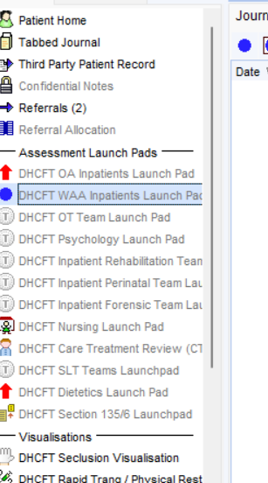

- Find Referrals template.
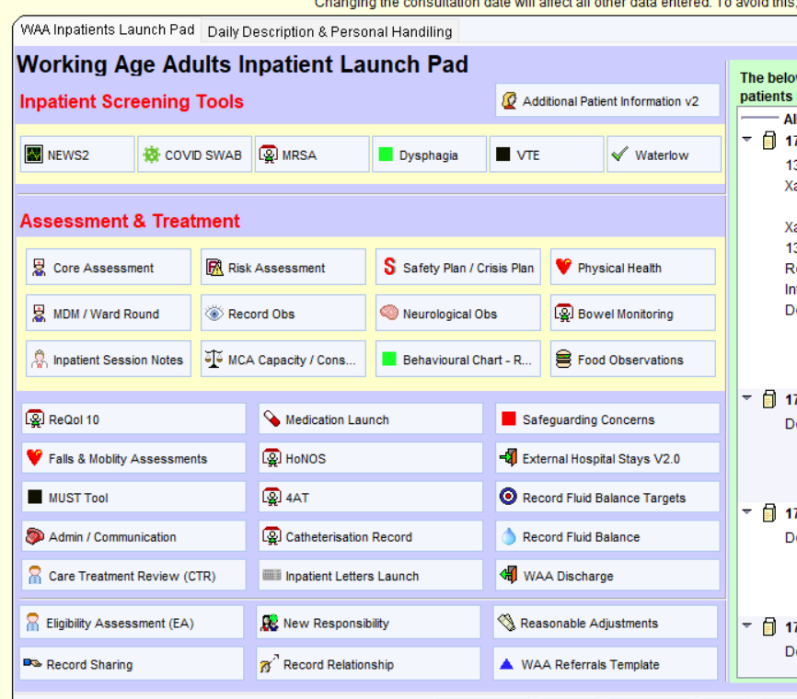

- Select Refer to HPU for tissue viability.
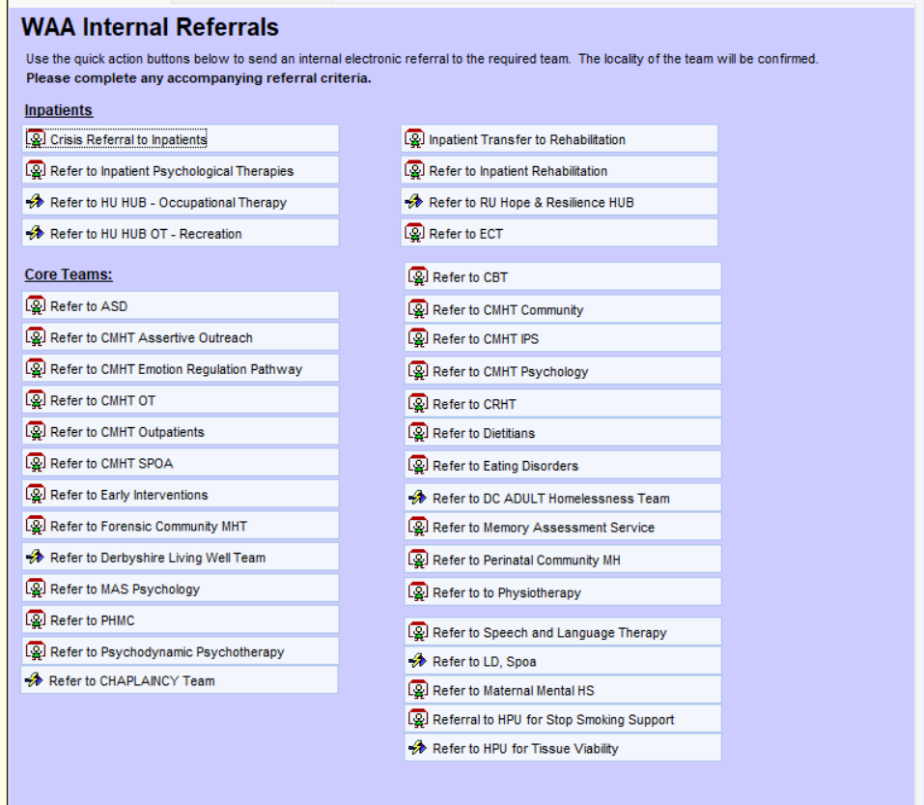

- Complete the form with as much information as possible in the Referral summary regards the need for referral and what has been done for the patient up to now.
